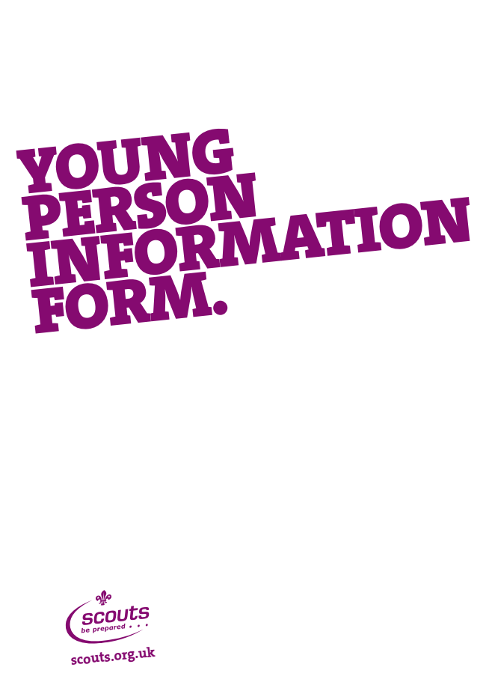
About this Form
This form is aimed at assisting in the collection of information regarding young people under 18 years of age, who are looking to join Scouting.
The information will be loaded onto Compass, The Scout Association’s online membership system and held locally in the Group spreadsheet.
Those young people aged 14 years and over should complete the Communications Preferences section and sign the form.
Parents/guardians should sign the form and return it to Hugh Gostling via their section leader.
Personal data will be stored on the system to support the application process and current and potential future involvement in Scouting. Some information is considered sensitive personal data under the Data Protection Act 1998 and as such will be managed as required under the act. Further information can be found at scouts.org.uk/dataprotection.
This information will also be held on computer for the Group’s use and will only be used for scouting purposes. The Group will not pass on your e-mail address to other parties outside of Scouting and will only use it to provide information about scouting events. The Group’s policy on handling personal data is provided to all adults in the Adult Welcome Pack and published on the website at http://www.claygatescouts.org/ as is an electronic copy of this form.

Communications
The Scout Association will not sell or promote products to those under 14 years of age. All communications to those under 14 will also be sent to parents/guardians.

Ethnicity and Religious Information
This information is requested by The Scout Association to help in monitoring its membership. The data will help the Association in understanding the makeup of the membership; monitoring progress against its inclusivity objective, and prioritising development work both nationally and locally, and will identify and help Leaders meet any specific needs of individuals.
Only the final page of the form will be retained by the Group.
Please complete the following information about your child in block capitals. Shaded boxes are compulsory fields on Compass and those fields marked with an asterisk* are for use by the Group only and will be stored on computers for the Group’s use.
Should you require any support with the completion of this form, please contact your section leader or Group Scout Leader.
Young Person’s Details
Surname
Forename(s) |  | Known as
Date of Birth |  | Gender M / F
Nationality
Address
 |  | Post Code
School/College/
University
Place of Worship*

Ethnicity (please tick appropriate box)
White | Black/African/Caribbean/Black British
- English/Welsh/Scottish/Northern Irish/British | - African
- Irish | - Caribbean
- Gypsy or Irish Traveller | - Any other Black/African/Caribbean background
- Any other White background | Other ethnic group
Mixed/multiple ethnic groups | - Arab
- White and Black Caribbean | - Other
- White and Black African
- White and Asian
- Any other mixed/multiple ethnic background | - Prefer not to say
Asian/Asian British
- Indian
- Pakistani
- Bangladeshi
- Chinese
- Any other Asian background

Religion or Faith (please tick as appropriate)
- Buddhist | - Sikh
- Christian (all denominations) | - Any Other Religion
- Hindu
- Jewish | - No Religion
- Muslim | - Prefer not to say

Contact Details
Email Addresses (Please indicate in the small box which email is your primary contact by ticking one only– for those under 14, any emails will automatically be sent to the nominated adult)
- Home
- Other
- Other

Telephone Numbers (Please indicate in the small box which phone number is your primary contact)
- Home
- Mobile
- Other

Medical Details
Doctor / Surgery
Surgery Address
 |  | Post Code
Telephone |  | NHS Number 10 digits)
Dietary Needs
Medical Information
Relatives or friends in the Group*

Additional needs/Disabilities (please tick those as necessary and provide details using the blank space below if necessary)

- Developmental |  | Developmental – ADHD/ADD, Autistic Spectrum Disorder, Dyslexia, Dyspraxia, Other
- Injury |  | Injury – Body, Brain
- Learning |  | Learning – Spina Bifida, Down’s Syndrome, Other
- Medical |  | Medical – Allergies, Arthritis, Asthma, Diabetes, Epilepsy, ME/Chronic Fatigue, Other
- Mental health |  | Mental Health – Bipolar, Depression, Eating Disorder, self-harm, Other
- Progressive |  | Progressive – Muscular Dystrophy, Other
- Sensory |  | Sensory – Hearing, Vision, Other

Contact 1 (Designated primary contact)
Parent/Guardian Information

Surname |  | Title
Forename(s) |  | Known as
Date of Birth |  | Gender M / F
Relationship

- Please tick here if the address is the same as the young person. If different, complete address details below.

Address
Post Code

Occupation |  | Occupation Details
- Employed
- Unemployed
- Retired (whether receiving a pension or not)
- Student
- Looking after home or family
- Long-term sick or disabled
- Other

Gift Aid Declaration (just one declaration – for the Primary contact here or the second parent below – needs to be signed)
Please treat all eligible donations, membership subscriptions and/or band subscriptions I make to 1st Claygate Scout Group, as Gift Aid donations. I confirm I have paid or will pay an amount of Income or Capital Gains Tax at least equal to the tax that 1st Claygate Scout Group reclaims on my donations in the appropriate tax year (currently 25p for each £1 given). Higher rate taxpayers may claim the difference between basic rate and higher or additional rate tax back via their self-assessment tax forms.

Signature: ……………………………………………………………………………………….. Date: ……………………..
If you stop paying Income Tax or Capital Gains Tax at some stage in the future please inform the 1st Claygate Scouts Group Treasurer to cancel this declaration.
Phone numbers
Primary phone number |  | Primary email
Second phone number |  | Second email
Third phone number |  | Third email

Contact 2 (please provide details of second parent if applicable)
Parent/Guardian Information

Surname |  | Title
Forename(s) |  | Known as
Date of Birth |  | Gender M / F
Relationship

- Please tick here if the address is the same as the young person. If different, complete address details below.

Address
Post Code

Occupation |  | Occupation Details
- Employed
- Unemployed
- Retired (whether receiving a pension or not)
- Student
- Looking after home or family
- Long-term sick or disabled
- Other

Gift Aid Declaration (just one declaration – for the second parent here or the primary contact above – needs to be signed)
Please treat all eligible donations, membership subscriptions and/or band subscriptions I make to 1st Claygate Scout Group, as Gift Aid donations. I confirm I have paid or will pay an amount of Income or Capital Gains Tax at least equal to the tax that 1st Claygate Scout Group reclaims on my donations in the appropriate tax year (currently 25p for each £1 given). Higher rate taxpayers may claim the difference between basic rate and higher or additional rate tax back via their self-assessment tax forms.

Signature: ……………………………………………………………………………………….. Date: ……………………..
If you stop paying Income Tax or Capital Gains Tax at some stage in the future please inform the 1st Claygate Scouts Group Treasurer to cancel this declaration. Phone numbers
Primary phone number |  | Primary email
Second phone number |  | Second email
Third phone number |  | Third email

Emergency Contact (for use during meeting if either parent not available)

Surname |  | Title
Forename(s) |  | Known as
Relationship
Primary phone number |  | Third phone number
Second phone number

Communications Preferences
The Association, at all levels, will use your details to contact you with information relevant to Scouting. Youth members 14 years of age and over should also confirm their communications preferences as we may contact them directly.
Additionally, from time to time we would like to contact you with details of news, products, offers and services from The Scout Association and local Scouting in your area (Group, District etc).
Let us know if you would prefer not to receive information about any of the following:
I do not wish to receive details: Contact 1 Contact 2 Young people aged 14 years and over
about Scout Activity Centres and campsites
of events and fundraising opportunities
from Scout Shops Ltd
of insurance for Scouting
Contacting you with the above information will support Scouting activities. All profits go straight back into Scouting to support the development of our leaders and growing Scouting around the UK, including areas where young people do not currently have the opportunity to join.
Partners or Third Parties
We may also have information, offers and opportunities for Scout members and supporters from carefully selected third parties or organisations that the Association may partner with

I am happy to receive information about third party or partner organisation offers and opportunities.
Contact 1 Contact 2 Young people aged 14 and over

The Scout Association will not transfer or sell your personal details to any third party organisations without consent or as required by law. Please note: You can amend your communications preferences online by editing your profile on Compass at any time.

Use of Photography
On occasions, photographs, videos and audio of Scouts taking part in activities may be submitted to the local newspapers, the Group, District or County newsletters, websites or put on display. The Group’s policy is published in the Group Welcome Pack which should accompany this form but if not is available on our website at http://www.claygatescouts.org/group_information.htm. Submission of this form assumes you agree to this policy but should you have any concerns please contact Hugh Gostling on 01372 469580.

Data Protection
As a registered Data Controller, The Scout Association is committed to the Data Principles of the Data Protection Act 1998.
By signing this form, I agree to the Scout Association during and beyond my child’s involvement with the organisation:
- Retaining personal data to facilitate any present or potential future involvement with Scouting;
- Retaining personal data regarding religion, special needs/disabilities, ethnicity, medical information and/or commission of offences or alleged offences
- Allowing access to personal data to appropriate individuals within the hierarchy of Scouting.
Contact 1 Contact 2 Young people aged 14 years and over
Sign |  | Sign |  | Sign

Print |  | Print |  | Print

Date |  | Date |  | Date

Behaviour Code
I have read the 1st Claygate Scout Group Behaviour Policy and Code in the Group Welcome Pack, with my child and agree to the rules and principles set out in it.
Signed (Parent):
Signed (Section Member ):
(Cubs, Scouts and Explorers only)

Offers of Help
It is a requirement of your child’s membership that you either help with a section, help with the general running of the Group or help with two fund-raising events per year. If you want further details on these please either contact your child’s section Leader, or Hugh Gostling.
Could you please indicate your preference below:
 | Father | Mother
Help with a section:
Help with section activities:
Have a relevant skill which could be of benefit (eg kayaking):
Have transport which could be used to shift equipment when needed:
Help with fund-raising:
Help with building maintenance:
Help with grounds maintenance
Please indicate if either of you have ever been involved in Scouting or Guiding as a member or helper

Any other offers? ……………………………………………………………………………………………………………………

